

DEDAN KIMATHI UNIVERSITY OF TECHNOLOGY

DEPARTMENT OF ELECTRICAL & ELECTRONIC ENGINEERING

FINAL YEAR PROJECT REPORT

PROJECT TITLE:
MONITORING AND CONTROL SYSTEM OF A POWER TRANSMISSION NETWORK USING STATCOM

Registration No. | Name | Signature
E021-01-0726/2019 | Delphine Chepngeno
E021-01-0725/2019 | Dennis Kimutai
E021-01-0724/2019 | Langat Kipchumba

SUPERVISOR: MS. SUSAN KISENGEU
A project submitted to the Department of Electrical and Electronic Engineering in partial fulfillment of the Award of Degree of Bachelor of Science in Electrical and Electronics Engineering.

NOVEMBER 2023

DECLARATION.
This project is our original work, except where due acknowledgement is made in the text, and to the best of our knowledge has not been previously submitted to Dedan Kimathi University of Technology or any other institution for award of degree or diploma.

NAME: DELPHINE CHEPNGENO REG NO: E021-01-0726/2019
SIGNATURE: ……………………………. DATE: …………………………………….

NAME: DENNIS KIMUTAI REG NO: E021-01-0725/2019
SIGNATURE: ……………………………. DATE: …………………………………….

NAME: LANGAT KIPCHUMBA REG NO: E021-01-0724/2019
SIGNATURE: ……………………………. DATE: …………………………………….

SUPERVISOR’S CONFIRMATION

This project has been submitted to the department of Electrical and Electronics Engineering, Dedan Kimathi University of Technology with my approval as the university supervisor.

NAME: MS. SUSAN KISENGEU

SIGNATURE: ……………………………. DATE: ……………………………………

ACKNOWLEDGEMENT
We greatly appreciate our supervisor, Ms. Susan Kisengeu for her continued guidance and helpful insights. Her commitment to the success of this project is our greatest motivation. We are also grateful to the Electrical and Electronic Engineering department, DeKUT, for providing us with enough resources to do our final year project.

Contents
DECLARATION. ii
ACKNOWLEDGEMENT iii
ABSTRACT ix
CHAPTER ONE: INTRODUCTION 1
1.1 BACKGROUND STUDY 1
1.2 PROBLEM STATEMENT 2
1.3 JUSTIFICATION 2
1.4 OBJECTIVES 3
1.4.1 MAIN OBJECTIVE 3
1.4.2 SPECIFIC OBJECTIVES 3
1.5 SCOPE OF STUDY 3
CHAPTER TWO: LITERATURE REVIEW 4
2.1 INTRODUCTION 4
2.2 POWER TRANSMISSION NETWORKS 4
2.3 REACTIVE POWER COMPENSATION 5
2.4 STATCOM WORKING PRINCIPLE 7
2.5 PREVIOUS WORKS 9
CHAPTER THREE: METHODOLOGY 12
3.1 SYSTEM MODELING 12
Sizing and integration of a STATCOM in an IEEE bus model 13
3.2 ANALYZING THE PERFORMANCE OF THE MODIFIED IEEE BUS SYSTEM 15
3.3 VALIDATING THE PERFORMANCE OF THE MODIFIED MODEL 16
3.3.1 FLOWCHART 17
3.3.2 STATCOM OPERATION 18
3.3.3 SYSTEM CONSTRAINTS 20
CHAPTER FOUR: RESULTS AND DISCUSSION 22
4.1 INTEGRATION OF A STATCOM IN AN IEEE 9-BUS SYSTEM 23
4.2 ANALYSIS OF THE PERFORMANCE OF THE MODIFIED IEEE 9-BUS TRANSMISSION SYSTEM WITH AND WITHOUT FAULTS 23
4.3 VALIDATING THE PERFORMANCE OF THE MODEL ON A FAULTED IEEE 9-BUS POWER TRANSMISSION SYSTEM 25
CHAPTER FIVE: CONCLUSION AND RECOMMENDATION 28
5.1 CONCLUSION 28
5.2 RECOMMENDATION 28
REFERENCES 29

LIST OF ABBREVIATIONS
STATCOM Static Compensator
DVR Dynamic Voltage Restorer
FACTS Flexible Alternating Current Transmission System
PCC Point of Common Coupling
ZSI Impedance Source Inverter
VSC Voltage Source Converter
MPPT Minimum Power Point Tracking
MMC Modular Multilevel Converters
UC Ultra Capacitor
VSI Voltage Source Inverter
ANN Artificial Neural Network

LIST OF FIGURES
Figure 2. 1: Single Line diagram of a typical Power System 5
Figure 2. 2: The power Triangle 6
Figure 2. 3: STATCOM-UC System 10
Figure 2. 4: STATCOM with VSI 10
Figure 3. 1: STATCOM System Block Diagram 12
Figure 3. 2: Complete IEEE-9 bus system. 15
Figure 3. 3: Data Acquisition System 16
Figure 3. 4: Components of Data Acquisition System 16
Figure 3. 5: System Flowchart 17
Figure 3. 6: STATCOM Transmission Line Structure 18
Figure 3. 7: Schematic Diagram of a Transmission Line including STATCOM 19
Figure 4. 1: IEEE 9-Bus Model with an integrated STATCOM 23
Figure 4. 2: Normally operating system 24
Figure 4. 3: System with line-ground fault 24
Figure 4. 4:System with line-line fault 25
Figure 4. 5: System with variable load 25
Figure 4. 6: STATCOM voltage and current correction 26
Figure 4. 7: STATCOM voltage correction 26
Figure 4. 8: STATCOM current correction 26
Figure 4. 9: STATCOM reference current comparison 27
Figure 4. 10: STATCOM PQ correction 27

LIST OF TABLES
Table 3.1: System Parameters 13
Table 3.2: IEEE 9-Bus Voltage and Data 14
Table 3.3: IEEE 9-Bus Generator Data 14

ABSTRACT
Power transmission networks in the world are continuously being monitored to ensure efficient operation and control. In recent times, researchers have done distributed and decentralized voltage control of smart transmission networks and innovative models for transmission network planning, operation, reconfiguration, and energy resources management in the smart grid paradigm. Industry specialists propose the use of reactive power compensation to improve energy efficiency by reducing the power consumption. Therefore, the cost is reduced, enabling optimum use of installations by preventing them from being oversized, and more generally improving the quality of energy systems. This project aims to present an efficient and effective way of mitigating the challenges associated with power quality. The project entails the design and simulation of impedance source inverter (ZSI) based Static Compensator (STATCOM). The system will analyze the power quality challenges, such as transients in power systems, harmonics and voltage sags with the application of STATCOM and the Dynamic Voltage Restorer (DVR). The model aims at maintaining the voltage stability of the system by either absorbing or generating reactive power. The STATCOM will be shunt connected to the system at the point of common coupling (PCC). The test model will be an IEEE 9-bus system owing to its relatively small size, which makes it more manageable for analysis and research purposes. The validation of the same will be achieved by use of a MATLAB Simulink model. Hence proving how a STATCOM compensates reactive power.

CHAPTER ONE: INTRODUCTION

BACKGROUND STUDY
Electrical power is generated by different types of power plants located in different areas. The power plants may be geothermal, solar, wind and hydro generated. The electrical power generated is then injected into the grid after being stepped up. The power is then transmitted to distribution centers then to the end consumers and various load centers through various distribution systems. The ultimate goal in power generation, transmission and distribution is the development of a well-coordinated system between the power grids and the distribution systems [1].
Generally, it is not feasible to design a power system network that prevents the occurrence of faults. Therefore, it is important to reduce the risk of voltage collapse and blackout while avoiding deterioration of the power quality due to its multilevel configuration. To realize maximization of returns in electrical power transmission and ensuring guaranteed customer satisfaction, the power systems must operate in a safe manner [2]. Variation in power consumption and demand mainly affects the power generation, transmission and distribution. The electrical power demands by the loads make it necessary to develop a framework for control and monitoring of the power transmission network to enhance the quality of power. It is, however, difficult to come up with informed prediction and the control of the total power generated in the grid [2]. In practice, there has been incorporation of different devices to enhance the compensation on the challenges that are related to the varying load demands. These devices include; the capacitor bank, voltage regulators and on-load tap changers. The incorporation of these devices in a power transmission system aims at meeting the objective of power loss reduction.
Power transmission systems suffer from the power quality problems that are related to both voltage and current being distributed. These challenges include voltage disturbances, poor power factor and distorted current [3]. Power quality in power transmission refers to maintaining of sinusoidal waveform of the bus voltage at the rated voltage frequency. STATCOM [4] is a power electronic converter-based device that used to protect transmission networks from voltage imbalances. This device is connected in shunt to the power transmission network to enhance the monitoring and control aspect of the network. With a view of enhancing power quality in a transmission network, a practical model is considered for analyzing of power quality issues such as voltage sags, harmonics and transients and with STATCOM and combine application of DVR and STATCOM compensation devices and are presented by MATLAB Simulink.

PROBLEM STATEMENT
The efficiency and reliable supply of electric energy in the transmission network is of great importance considering the fact that electricity has been incorporated in most of the daily human activities. Monitoring the power transmission system is a big concern in ensuring an interruption-free power supply and that those human activities relying on the electric power are uninterrupted. Power quality is guaranteed by developing of frameworks to mitigate the power transmission challenges that include the transient in power system, over voltages and under voltages, harmonics and poor power factor. The existing ways of ensuring power quality in a transmission network have their own shortcomings. For instance, the use of shunt capacitors and adjustable speed motors increases the harmonic level of the power system. It is therefore important to develop an effective monitoring and control system for power transmission networks hence preventing short circuit faults, keeping the tract of available generation and enable effective and efficient load management [2]. The system is cost effective and more efficient as compared to the other methods of enhancing power quality.

JUSTIFICATION
Reliable transmission of electrical power requires continuous monitoring of the transmission network by enhancing real time analysis of the system parameters such as voltage, current and power factor. There is a need to track the variation in these system parameters in order to control system operation and stability. To satisfy this need, a monitoring and control system has to been developed for electrical power transmission networks to improve its efficiency and mitigate the challenges related to faults. This system will contribute to the reliability and efficiency in power transmission and fault correction. Coming up with a system that guarantees real time monitoring and control in electrical transmission network is important as it improves power quality and enhances the reliability of power system for those industrial application that require continuous power supply.

OBJECTIVES

MAIN OBJECTIVE
To monitor and control a power transmission network using a Static Compensator (STATCOM).

SPECIFIC OBJECTIVES
- To size and integrate a conventional STATCOM in an IEEE 9 bus test system.
- To analyze the performance of the modified IEEE 9 bus power transmission system with and without faults.
- To validate the performance of the model on a faulted IEEE 9 bus power transmission system.

SCOPE OF STUDY
This project includes the design of a monitoring and control scheme for an IEEE test system. It provides monitoring services on the line to mitigate the effects of faults including over-voltages, under-voltages, PQ problems, harmonics, load balancing and power-voltage regulation problems. The system also seeks to provide control measures to counter the identified problems. This monitoring and control scheme is developed for IEEE 9 bus three-phase transmission network. The operation of the system is analyzed under normal condition and compared with the operation of the same system under fault. The challenges related to the fault mitigated by applying the STATCOM control system.

CHAPTER TWO: LITERATURE REVIEW

2.1 INTRODUCTION
The continuous development of technology and growth of the industrial sector has led to increase in the demand for electrical power. This means that more power has to be generated and hence transmitted. With the move to meet the demands of the customers, electrical utility companies need to ensure the continuity of power generation and supply to the customers. This has called for development of integrated systems that controls and monitor the performance of the electrical power transmission systems. This has been made possible by the advancement of power electronic devices in the recent years. Because of the development and advancement, mitigation of the power transmission challenges has been made easy and thus improving the power quality supplied to the consumers by the utility companies [5]. Power losses in the electrical power distribution systems are also reduced. STATCOM is an efficient member of the distributed Flexible AC transmission systems where it can regulate the bus voltages by injection or absorption the reactive power. STATCOM is a voltage source converter (VSC) tied to DC bus which is joined by a coupling transformer and an along with a harmonic filter [6].

2.2 POWER TRANSMISSION NETWORKS
Power transmission is the process by which large amounts of electricity produced at power plants (such as hydro, geothermal, thermal and wind), is transported over long distances for eventual use by consumers [2]. Due to the large amount of power involved, and the properties of electricity, transmission normally takes place at high voltage (132-kilovolt or above) to reduce losses that occur over long distances.
Power is usually transmitted to a substation near a populated area. At the substation, the high voltage electricity is converted to lower voltages suitable for consumer use, and then transmitted to end users through relatively low-voltage electricity distribution lines that are owned and operated by the national electricity utility.

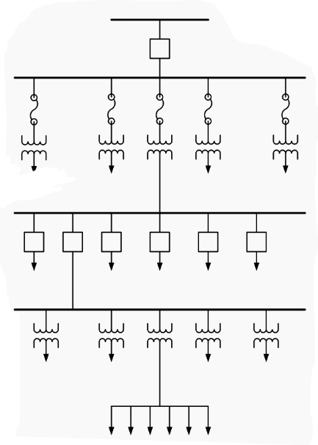
Main Laterals
Distribution Transformer
Service Main

Distribution Sub-Station
Bulk Power Source
Secondary Transmission System
Primary Distribution System
Consumer End
Figure 2. 1: Single Line diagram of a typical Power System
IEEE has developed several test systems for transmission networks. These test systems are used to verify models and methodologies regarding reconfiguration and operation of transmission networks.

2.3 REACTIVE POWER COMPENSATION
Electrical power is defined as the rate at which electrical energy is transformed by an electric circuit. For a simple DC circuit, its defined as the product of voltage times current. Mathematically: V = IR.
For AC circuits, we have three types of powers:
Real or Active Power: This is the actual power that is supplied from load to the source. Its unit is watts
Reactive Power: This is the power that continuously bounces back and forth between source and load. Reactive power is measured in volt-amperes reactive, 1var = 1V * 1A
Apparent power: this is the product of the r.m.s voltage and the r.m.s current. It is denoted by (S) and measured in units of Volt-amp (VA).
The power triangle below shows the relationship between the three powers. Where the power factor is the ratio between active power and reactive power.
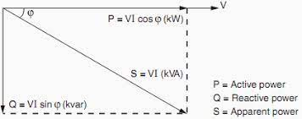
Figure 2. 2: The power Triangle

The frequency of a system is dependent on active power balance between generation and demand. A change in active power demand at one point is reflected throughout the system by a change in frequency. Reactive power on the other hand is required to maintain the voltage to deliver active power through transmission lines, when there is not enough reactive power, the voltage sags down and it is not possible to push the power demanded by loads through the lines [7].
To attain voltage control, reactive power compensation is necessary. This is the process of adding or injecting positive and/or negative VAr’s to a power system network. Some of the components used to achieve this include three phase capacitors, capacity duty contactors, power factor controlers, and three-phase harmonic filters.
The major reasons for the need to do reactive power compensation in AC transmission systems are:
  - The voltage regulation.
  - Increased system stability.
  - Better utilization of machines connected to the system.
  - Reducing losses associated with the system.
  - To prevent voltage collapse as well as voltage sag.
The STATCOM is mainly used to compensate the power quality problems [4]; i.e volatage dips, current quality, harmonic distortion and unbalanced load problems: current reactive component, unbalanced and neutral current at the point of common coupling (PCC).

2.4 STATCOM WORKING PRINCIPLE
STATCOM is a converter based shunt connected device used to regulate the bus voltage by either absorbing or generating reactive power. It incorporates the following parts;
- DC capacitor
- Voltage Source Inverter.
- Coupling Transformer
- Reactor
It operates by compensating either bus voltage or line current. Accordingly, it works on two modes;
- Voltage mode operation
In this mode, the bus voltage connected to device is made sinusoidal irrespective of the harmonics in the supply voltage.
- Current mode operation
Irrespective of the load current distortions, STATOM forces the source current connected to it to be a balanced sinusoid.
The working principle of a STATCOM in voltage sag mitigation is to regulate the bus voltage by generating or absorbing the reactive power. Thus, the STATCOM operates as an inductor or as a capacitor depending on the magnitude of the connected bus voltage [4].
CONTROL AND COMPENSATION STRATEGIES
a) Voltage control strategies
A voltage control strategy that uses multiple STATCOMs is applied to a low voltage network in order to anticipate voltage support. The multiple STATCOMs share the required reactive power. For low voltage distribution grids, a voltage regulator using STATCOM is used [4]. The low pass filter (second order) is used to connect the STATCOM. Its control structure provides active damping with the help of the two dc bus loops and three output voltage loops. The STATCOM is forced to operate with minimum power due to introduction of new idea to bring no compensation in certain conditions or in other words Minimum Power Point Tracking (MPPT). These three output voltage loop reduces apparent power processed by converter to nearly about 32 % and with the use of light load (95 %). A three phase STATCOM which is based on modular multilevel converters (MMC), uses voltage control strategy.
b) Current Control Strategies
STATCOM compensates load functions. In order to regulate time varying active and reactive power control, an extra current control loop system is used under the fluctuations of load. Synchronous detection method is used to analyze the shunt compensator characteristics.
c) Inverter Technologies for STATCOM
High voltage and low voltage transmission system using single dc capacitor are not capable of providing full compensation with three phase and three legs VSI. This drawback is overcome by using neutrally clamped DC capacitor topology. It still suffers from unbalanced capacitor that brings the requirement of an extra circuit for balancing and affects the overall cost of compensator cost. An alternative solution to the problem is using three single phase inverter which are independent along with single DC capacitor.
d) Voltage and current control strategies
Compensation of parameters like elimination of harmonics, correction of power factor, and regulation of voltage, is achieved by using adaptive theory for hardware implementation of three phase STATCOM. Digital signal processor is used to compare performance analysis of STATCOM model. The STATCOM with both PCC and DC bus voltages are regulated while using unbalanced loads [4].
e) Artificial Neural Networks
Power factor and reduction in line current harmonics of the network is reduced using a hybrid controller. To push the source current into a sinusoidal one and tries to be in phase with line voltage the controller is used in the network. It provides two controls estimation of weighting factor of three phase load current and hysteresis switching algorithm for driving the VSC of STATCOM. The compensator is optimized using an ANN with suitable learning rate [6].

2.5 PREVIOUS WORKS
There are approaches that have been used to mitigate power quality challenges in power transmission networks. Various solutions, proposing the application of FACTS systems have been presented in different papers.
In [8], the power system stability and oscillation monitoring and control is achieved by improving the response of the STATCOM by including a relatively fast-acting energy storage systems in the control systems. This project proposes the use of ultra capacitor besides the STATCOM in the case of three phase fault occurring in power transmission systems. The system is modeled, describing the terminal behavior of Electric double layer capacitor units over a range of frequency, from DC to several thousands of Hertz. It consist of voltage source inverter (VSI), coupling step up transformer, line filter, DC bus capacitor, bulk boost converter and the bank of Ultra-capacitor.
STATCOM coupled with an Ultra capacitor acts as a synchronous three phase machine which can generate AC voltage with controllable amplitude and phase angle at its terminal. This system’s response is almost instantaneous since it has no inertia. STATCOM injects reactive power to the transmission grid in order to control the frequency and voltage of the system to minimize oscillations and stability characteristics after the occurrence of faults. It is, however, presented in [9] that there are limitations of using Ultra capacitors in controlling the power systems parameters. Based on the experimental results and various derivations, it is revealed that there are limitations on the use of Ultra capacitor (UC) in power systems. The upper limit of SC voltage imposes certain limits on power and energy capabilities of the power systems. It concluded that some of the performance figures used in datasheets are strictly theoretical and cannot be achieved in practice.
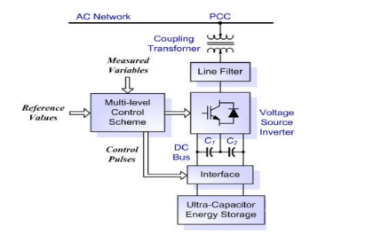
Figure 2. 3: STATCOM-UC System
According to [10], power quality improvement can be enhanced by VSI based STATCOM. The system is developed as follows,
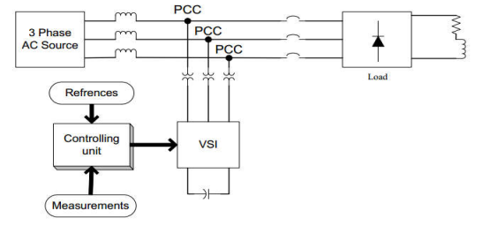
Figure 2. 4: STATCOM with VSI
The comparison of the system operation with that of the Z-source inverter based control system and the analysis of the power systems under the control of the same checked for both power factor and the operation on load balancing. STATCOM can be used in the power transmission systems with inductive loads to improve power factor. From the results of the operation of VSI based STATCOM control, it is noted that the power factor of the system is improved from about 0.9506 for a system without STATCOM to about 0.9567 for a system with VSI based
STATCOM control system. It is therefore important to note that VSI based STATCOM enhances the improvement of the power factor in power transmission systems. However, the improvement of power factor for the VSI based STATCOM controlled power system is lower as compares to that of Z-Source Inverter (ZSI) STATCOM.

CHAPTER THREE: METHODOLOGY
This chapter gives a vivid discussion on the actual steps that we will follow to help in realization of the project. The presentation of the steps followed to come up with the designed system to monitor and control power transmission networks and mitigate the challenges associated with the power transmission networks. The ZSI based STATCOM system that incorporates the DVR will be used to enhance an efficient monitoring and control process on power transmission systems. With the simulation of the system done on MATLAB SIMULINK and various tests cases conducted on IEEE nine-bus system in order to appreciate its importance on the power transmission networks and the operation of the electric power circuits that incorporate the system developed. Among the parameters to be monitored by the system are voltage stability in power systems, load balancing and frequency waveforms of the system.

3.1 SYSTEM MODELING
THREE PHASE AC SOURCE
SERIES TRANSFORMER
LOAD
COUPLING TRANSFORMER
STATCOM
DYNAMIC VOLTAGE RESTORER
Figure 3. 1:STATCOM System Block Diagram
The system is composed of a three phase source that supplies electrical power. The electrical power supplied from the source is transmitted to the load end through the transmission lines. The transmission line is fitted with the STATCOM modelled controlled system. STATCOM is shunt connected to the transmission system through a coupling transformer as shown in the block diagram.
Sizing and integration of a STATCOM in an IEEE bus model
An IEEE 9 bus system was considered in evaluating the performace of the STATCOM monitoring and control system. The following data being used in in evaluating the system;
Table 3.1: System Parameters
Bus No.  From | Bus No.  To | (Ohms/km)  [r1 r0] | (H/km)  [11 10] | (F/km)  [c1 c0] | Line Length  (km)
7  8  7  9  5  4  2  9  1 | 8  9  5  6  4  6  7  3  4 | 0.044965 0.11241  0.054 0.163  0.095 0.287  0.105 0.315  0.054 0.162  0.093 0.281  0.000 0.000  0.000 0.000  0.000 0.000 | 1.225e-3 4.287e-3  0.0012 0.0036  0.0012 0.0038  0.0012 6.0036  0.0012 0.0036  0.0013 0.0040  0.000 0.000  0.000 0.000  0.000 0.000 | 9.010e-9 2.574e-9  9.073e-9 2.721e-8  8.687e-9 2.606e-8  9.144e-9 2.743e-8  9.06e-9 2.720e-8  8.257e-9 2.477e-8  0.000 0.000  0.000 0.000  0.000 0.000 | 98.95  115.56  176.71  196.41  97.38  95.99  0.000  0.000  0.000

Table 3.2: IEEE 9-Bus Voltage and Data
Bus No. | Bus Type | Bus Voltage (kV) | Angle Degree | Load [P(MW), Q(Mvar)]
1 | Slack | 16.5 | 0 | 0
2 | Voltage | 18 | 0 | 0
3 | Voltage | 13.8 | 0 | 0
4 | Load | 25 | 0 | 0
5 | Load | 25 | 0 | 1
6 | Load | 25 | 0 | 0.5
7 | Load | 25 | 0 | 0
8 | Load | 25 | 0 | 0.6
9 | Load | 25 | 0 | 0

[11]
Table 3.3: IEEE 9-Bus Generator Data
Generator | Voltage (kV) | Active Power Capability (MW) | Reactive Power Capability (kVAR)
G1 | 16.5 | 71.6 | 27
G2 | 18 | 163 | 6.7
G3 | 13.8 | 85 | -10.9

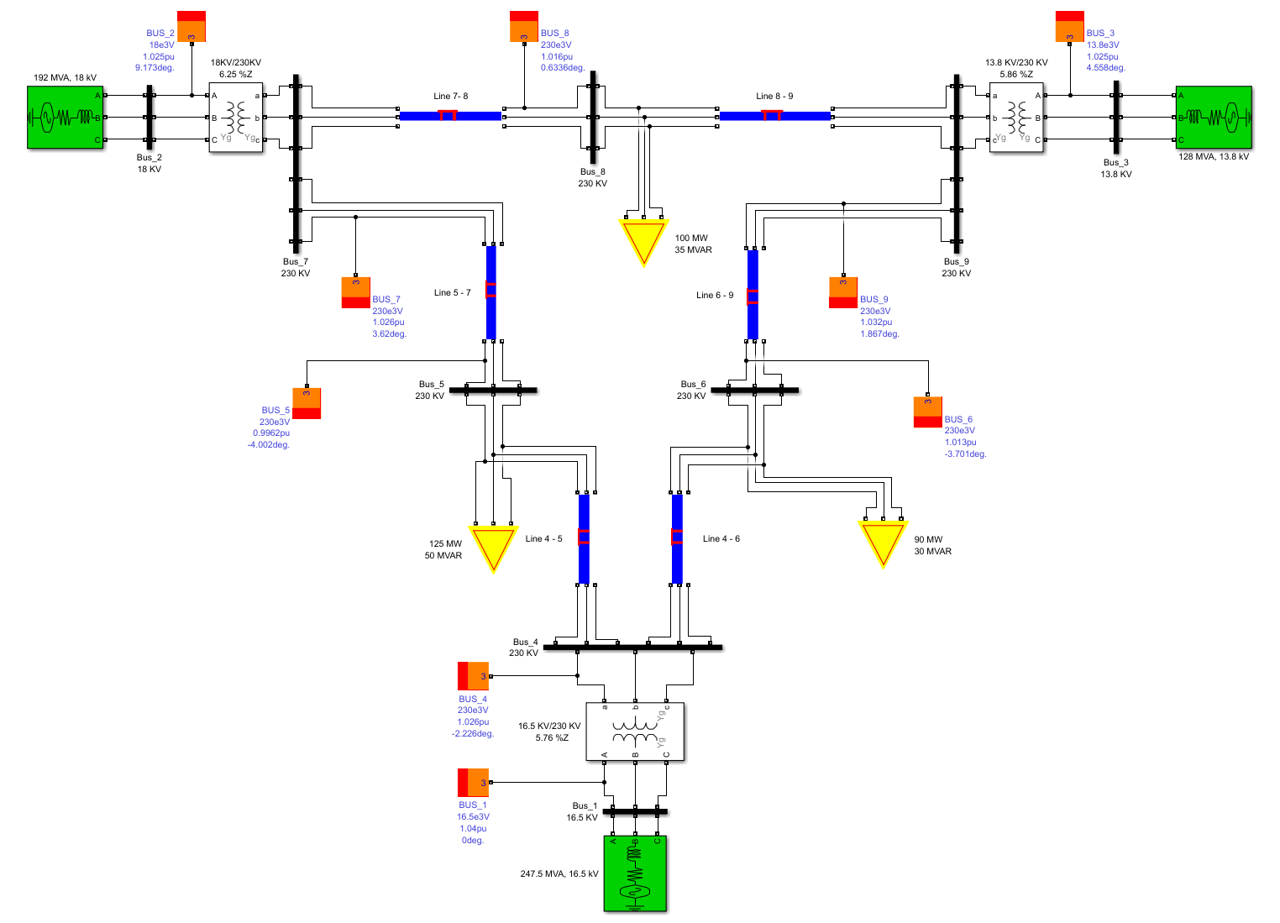
Figure 3. 2: Complete IEEE-9 bus system.

3.2 ANALYZING THE PERFORMANCE OF THE MODIFIED IEEE BUS SYSTEM
The data acquired from the controlled system are presented in three scopes.
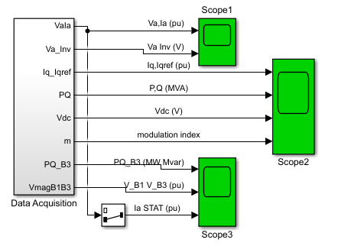
Figure 3. 3: Data Acquisition System
The Data acquisition model is as shown in the figure below. It shows the way the data is acquired from the interconnected buses and the same presented in the three scopes.
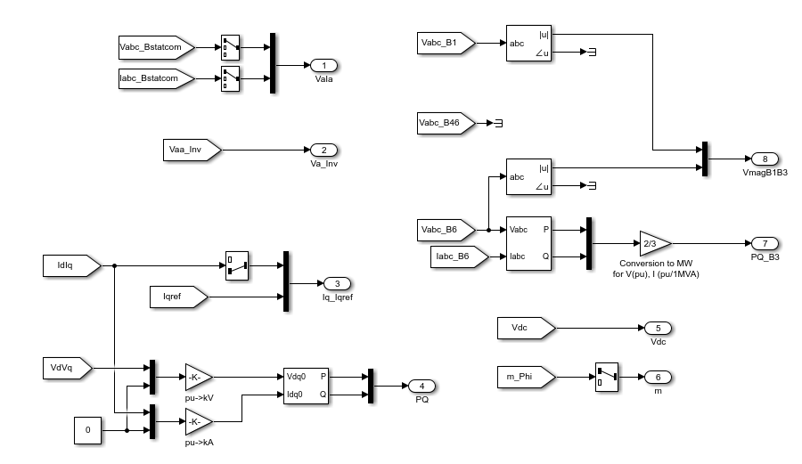
Figure 3. 4: Components of Data Acquisition System

3.3 VALIDATING THE PERFORMANCE OF THE MODIFIED MODEL

3.3.1 FLOWCHART
NO
START
Design IEEE 9-Bus System Using MATLAB
Analyze the System Parameters Without STATCOM
Introduce Three Phase Distortion and Run the System
Varied System’s Operation?
Analyze the operation in the system and its parameters
STOP
YES
Insert STATCOM control system
Figure 3. 5: System Flowchart
The figure above shows the workflow of the monitoring and control system developed. The designed STATCOM monitoring and control system is connected to the faulted IEEE 9 bus system whose operation has been analyzed. The operation of the system both with fault and without fault is presented in the scopes and the variation of the system’s operations is analyzed. The corrective measure is applied by the connection of the designed model to the system to mitigate the challenges related to power transmission problems resulting from the fault. The outcome of connection of the control system is analyzed based on the results of the different scopes. The process is then terminated.

3.3.2 STATCOM OPERATION
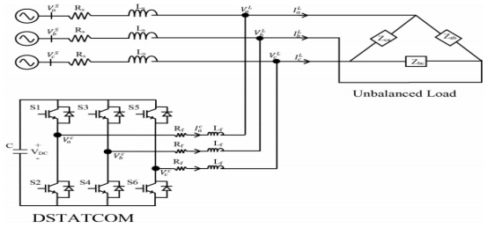
Figure 3. 6: STATCOM Transmission Line Structure
STATCOM is shunt connected with the load while the rest of the system is simplified as an infinite utility voltage source with source impedance , STATCOM eliminates or mitigates the unwanted effects such as reactive power, harmonics, and unbalance in the load currents. The STATCOM supplies the unbalanced currents to compensate for the unbalance load. This results in balanced currents being drawn from the utility, improving the power quality and thereby not affecting other loads connected to the system.
- DC bus voltage (Vdc)
The minimum dc bus voltage of VSC should be greater than twice the peak of the phase voltage of the system.
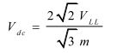
Where m=modulation voltage of STATCOM
index (here m=1), VLL=ac line
- Interfacing Inductor (Li):
The selection of interfacing inductor Li of VSC depends on the current ripple (Icr (p-p)), switching frequency (Fs) and DC bus voltage (Vdc).
$$L_{i}=\frac{\sqrt{3}mV_{dc}}{12aF_{s}i_{cr(p-p)}}$$
Where a=overloading factor
- DC bus capacitor (Cdc)
The value of DC capacitor (Cdc) for VSC depends upon the instantaneous energy available to STATCOM during transient.
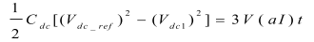
Where Vdc1=minimum voltage level of DC bus, V=phase voltage, I=phase current.
IV.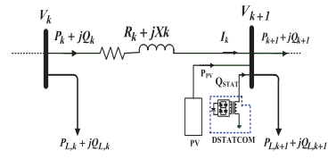
Figure 3. 7:Schematic Diagram of a Transmission Line including STATCOM
$$P_{k+1}=P_{k}-P_{L,k+1}-R_{k,k+1}\left(\frac{{P_{k}}^{2}+j{Q_{k}}^{2}}{{|V_{k}|}^{2}}\right)$$
$$Q_{k+1}=Q_{k}-Q_{L,k+1}-X_{k,k+1}\left(\frac{{P_{k}}^{2}+j{Q_{k}}^{2}}{{\left|V_{k}\right|}^{2}}\right)+Q_{DSTAT}$$
Where,$X_{k,k+1}$ and $R_{k,k+1}$are reactance and resistances of the line between buses n and k+1, respectively and $P_{k}$ and $Q_{k}$ are the real and reactive powers flows respectively. Active power loses and reactive power loses are given as follows.
$$P_{loss(k,k+1)}=R_{k,k+1}\left(\frac{{P_{k}}^{2}+j{Q_{k}}^{2}}{{|V_{k}|}^{2}}\right)$$
The voltage stability index is presented as follows,
〖VSI〗_((k+1))$={|V_{k}|}^{2}-4{\left(P_{nk+1}X_{k}-{Q_{k+1}R}_{k}\right)}^{2}-4\left(P_{nk+1}X_{k}+{Q_{k+1}R}_{k}\right){|V_{k}|}^{2}$
Where ${VSI}_{(k+1)}$ is the voltage stability index. The voltage deviation can be given as;
$$VD=\sum_{h=1}^{n}{|V_{n}-1|}$$
Where n is the number of system nodes.
STATCOM is minimizing the power loss, the system stability improvement and the voltage profile enhancement [12].

3.3.3 SYSTEM CONSTRAINTS
Power system constraints can be categorized as follow;
Equality constraints
The equality constraints include the active and reactive powers flows in power systems and can be given as;
$P_{s}=\sum_{h=1}^{np}{\left(P_{D}(h)\right)}$+$\sum_{h=1}^{nl}{\left(P_{loss}(j)\right)}$
$$Q_{s}+\sum_{i=1}^{nc}{Q_{DSTAT}}(i)=\sum_{h=1}^{n}{Q_{D}(h)+}\sum_{j=1}^{nl}{Q_{loss}(j)}$$
Where $P_{s}$ and $Q_{s}$are the supplied active power and the supplied reactive power in the bus. $P_{D }$and $Q_{D}$ are the active load and reactive load respectively. $nl$ is the number of the transmission lines and $nc$is the number of STATCOMs .
Inequality constraints
- Bust voltage limits
Where, $V_{min}$ and $V_{max}$ are the lower and upper voltage limits.

Total injected reactive power limit
The reactive power of the STATCOM should equal or less than the reactive load.
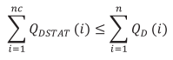
Where, $Q_{D}$is the reactive load and $Q_{DSTAT}$is injected reactive power by STATCOM.

Total injected active power limit
The reactive power of the STATCOM should equal or less than the reactive load.

CHAPTER FOUR: RESULTS AND DISCUSSION
This chapter presents the results of our project. The presentation of variations in power transmission system performance, both when working normally and when the distortions are introduced is done in this chapter. The solutions to the distortions are then met by applying our monitoring and control system. The analyzed output of our modelled system on IEEE 9 Bus has been well presented and explained. The application of STATCOM modelled to mitigate the power transmission challenges and its applicability in ensuring that we get a more efficient system is well presented in this chapter. The challenge that results from the variable load connected to bus 6 affects the transmission system and the same has been mitigated by the application of our STATCOM model. When the STATCOM model is connected, reactive power is compensated and the voltage flickers are mitigated. STATCOM regulates and control voltage in bus 6 by absorbing or injecting reactive power. When the STATCOM output voltage is lower than that of Bus 6, the STATCOM absorbs reactive power from bus 6. In case the secondary voltage is higher than that of Bus 6, the STATCOM compensates reactive power in the bus.
The simulation in our system was performed in three steps;
- The analysis of the operation of IEEE 9 bus transmission system without three phase distortion in any part of the system.
- Introduction of distortions and checking the variation in the system operation.
- Introduction of STATCOM monitoring and control system and analyzing its applicability in mitigating the challenges as a result of the three-phase distortion.

4.1 INTEGRATION OF A STATCOM IN AN IEEE 9-BUS SYSTEM
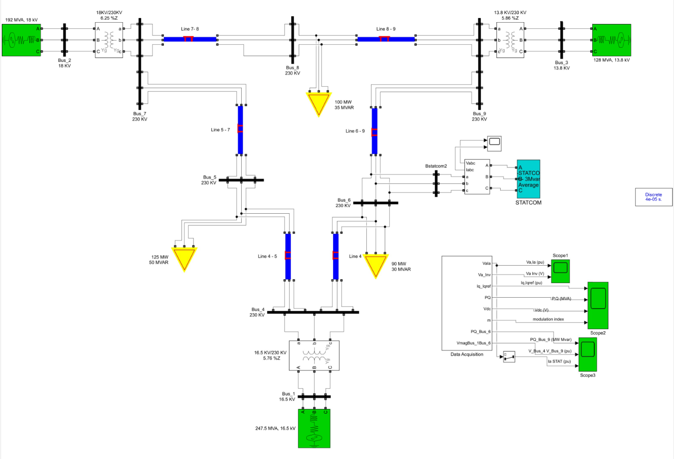
Figure 4. 1: IEEE 9-Bus Model with an integrated STATCOM

4.2 ANALYSIS OF THE PERFORMANCE OF THE MODIFIED IEEE 9-BUS TRANSMISSION SYSTEM WITH AND WITHOUT FAULTS
The figure below presents the waveform of a normally operating system. A system operating normally is stable and there is no variation in both voltage and current. It operates as per the rated voltage and current in the system. The presentation of a normally operated systems is done by the use of scopes. The scopes present sinusoidal waveforms for the system, the three phases are equal in magnitude and are out of phase at an angle of 120⁰. This clearly presents the stability of the system.
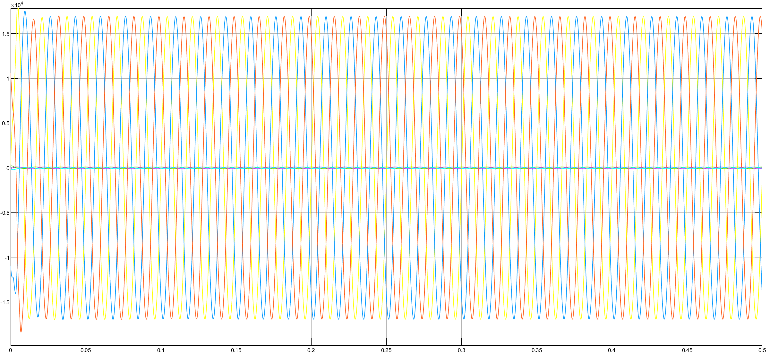
Figure 4. 2: Normally operating system
FAULTED SYSTEM WITHOUT STATCOM
THREE PHASE FAULT
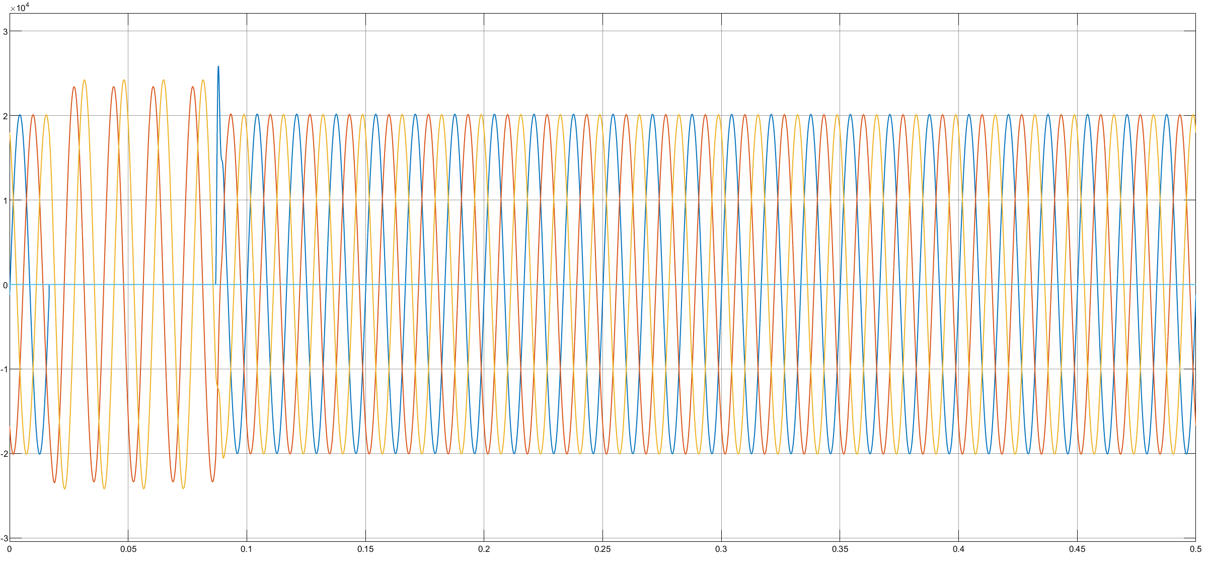
Figure 4. 3: System with line-ground fault

The figure shows the effect of a line to ground fault in a power transmission system. As shown, the Red phase has a line to ground fault that persist for quite some time before the system coming back to normal. The normal operation of the system is affected. Below is the figure presenting the effect of line-to-line faults in a system. There is a fault between the yellow phase and the blue phase, affecting the system’s operation as shown.
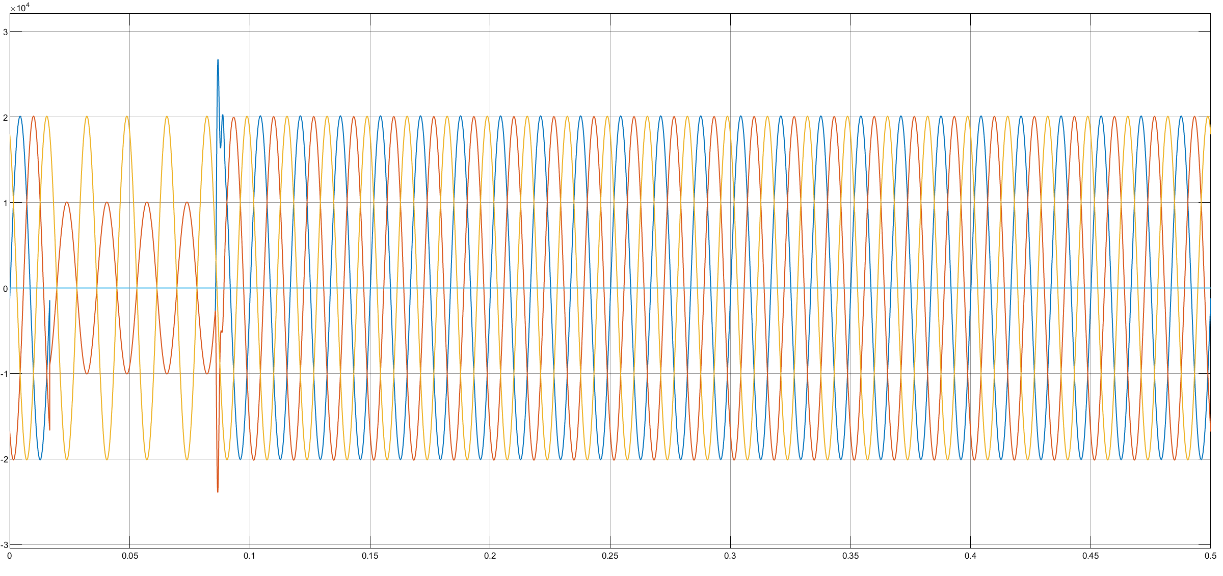
Figure 4. 4:System with line-line fault

UNBALANCED LOAD
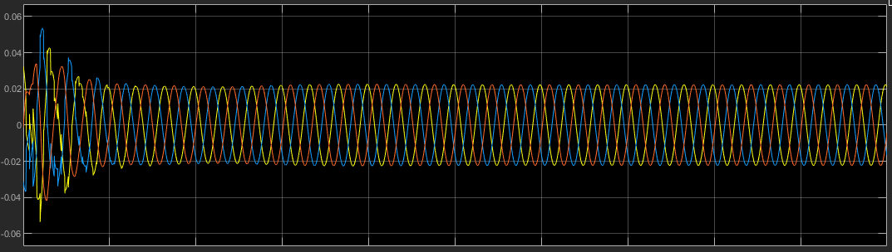
Figure 4. 5: System with variable load
When the system is connected with the unbalanced load, the load draws changing current continuously producing voltage flickers. Its apparent power varies continuously, making the system unstable.

4.3 VALIDATING THE PERFORMANCE OF THE MODEL ON A FAULTED IEEE 9-BUS POWER TRANSMISSION SYSTEM
FAULTED SYSTEM WITH STATCOM
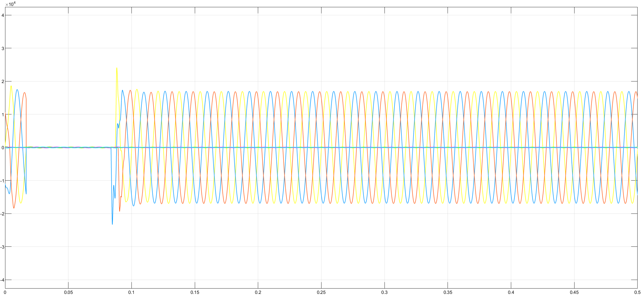
Figure 4. 6: STATCOM voltage and current correction

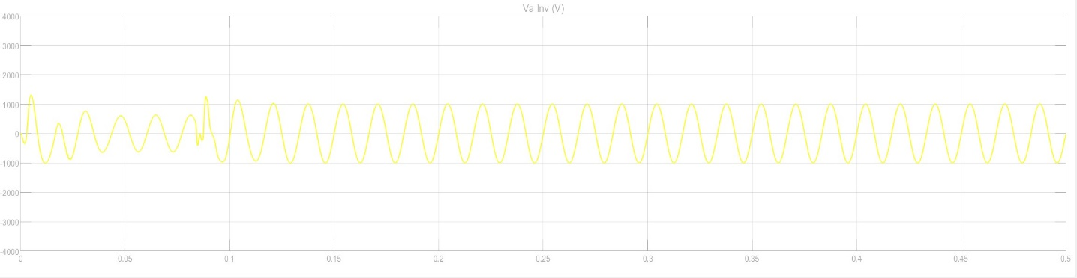
Figure 4. 7: STATCOM voltage correction
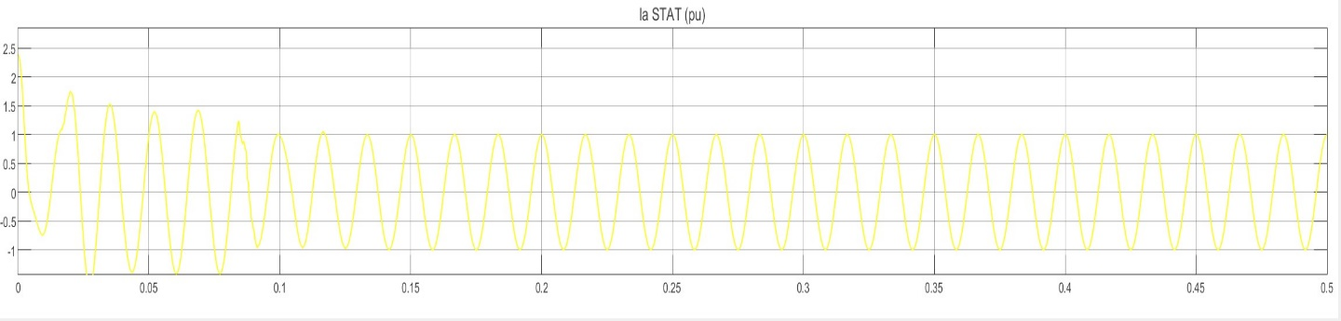
Figure 4. 8: STATCOM current correction
To show the effectiveness of the STATCOM in harmonics and power factor compensation, the power system performance was investigated under variable load condition. The fig shown above shows the MATLAB simulation results before and after the STATCOM was connected. After 0.1 s the STATCOM was connected and was able to compensate and make the source current and voltage sinusoidal. The total harmonic distortions are effectively reduced to restore the system performance. As it can be seen from the figure, before the STATCOM is connected to the system the source current and voltage were highly distorted with Total Harmonic Distortions. When the STATCOM is enabled after 0.1s, it can be seen that the source current and voltage become sinusoidal with less Total Harmonic Distortions. 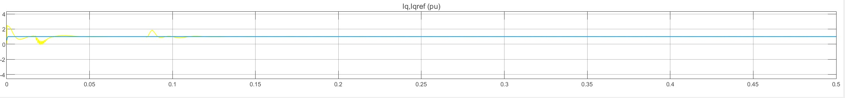
Figure 4. 9: STATCOM reference current comparison
Before STATCOM is enabled, it can be seen that the harmornic distortion is present in the current and system current is different from the reference current. Once STATCOM is enabled and harmonic distortions reduced, the system current is corrected and becomes equal to the reference current set. After the STATCOM is enabled at 0.1s, good tracking between STATCOM measured and reference current is shown.
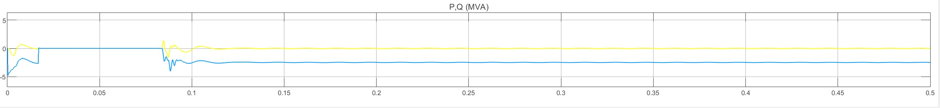
Figure 4. 10: STATCOM PQ correction
It can be seen that before the STATCOM is connected all the reactive power required by the load is supplied by the source, and after STATCOM is enabled the source reactive power dropped to zero and the STATCOM starts to provide the required VAR and harmonic compensation.

CHAPTER FIVE: CONCLUSION AND RECOMMENDATION

5.1 CONCLUSION
Our project has demonstrated the application of STATCOM monitoring and controlling of power transmission systems. The modelled system presents the excellent performance of STATCOM in improving power system stability in times of distortions in the power system. It is observed that STATCOM compensate capacitive reactive power, mitigates the sags that results from the connected unbalanced loads in the respective bus. STATCOM, mitigates the harmonic pollution at the source, thus preventing the propagation of undesirable harmonics, which can disrupt the smooth operation of other devices and can lead to overheating issues in lines and substation transformer windings. Its efficiency in mitigating the power system challenges is high as it is fast. Once enabled, it takes short time to restore the normal operation of the system. It is therefore more reliable to use.

5.2 RECOMMENDATION
Having presented the reliability of our system in mitigating the challenges affecting the power system transmission network, we would like to recommend the use of STATCOMs in reactive power compensation to absorb or generate reactive power in synchronization with the demand to stabilize the voltage of the power network. This makes them particularly useful for managing the reactive power in transmission lines.
We recommend that improvements of the system can be done in future to incorporate measures of detecting the specific location of faults.

REFERENCES

[1] | T. Short, Electric Power Distribution Handbook., Florida, USA: CRC Press., 2014.
[2] | T. Gonen, Electrical Power Transmission System engineering: Analysis and Design ., vol. 2, CRC Press, 2014, pp. 116-129.
[3] | M. Rahmani-Andebili, Power System Analysis, Cham: Springer, 2021.
[4] | W. F. M. T. E. K. G. Gupta, "A comprehensive review of STATCOM: Control and compensation strategies," Int. J. Appl. Eng. Res , vol. 12, no. 12, p. 3387–3393, 2017.
[5] | B. Singh, Power Quality; Problems and Mitigation Techniques, Hoboken: Wiley , 2015.
[6] | A. K. P. S. K. S. a. M. M. T. Penthia, ANN controlled 4-leg VSC based STATCOM for power quality enhancement,” 12th IEEE Int. Conf. Electron. Energy, Environ. Commun. Comput. Control (E3-C3), INDICON 2015, pp. 17–22, 2016, doi:, Chicago: IEEE, 2015.
[7] | W. Hofmann, Reactive Power Compensation: A Practical Guide,1st Edition, Hoboken: Wiley, 2012.
[8] | B. V. a. M. A. N. G. Khani, " “a New Approach To Improve Distribution Power Grids Stability By Using Ultra Capacitor Beside,”," vol. 25, no. 1, p. 41–47, 2013.
[9] | M. M. e. al, "“Performance and limitations of a constant power-fed supercapacitor,”," IEEE Trans. Energy Convers, vol. 29, no. 2, p. 445–452, 2014.
[10] | R. P. K. a. P. Nijhawan, "“Performance Comparison of VSI Based STATCOM and ZSI Based STATCOM in A Distribution System Network,”,," IOSR J. Electr. Electron. Eng., vol. 9, no. 6, pp. 30-35, 2014.
[11] | M. E. a. S. K. A. Ramadan, "“Performance Assessment of a Realistic Egyptian Distribution Network Including PV Penetration with STATCOM,”,," Proc. 2019 Int. Conf. Innov. Trends Comput. Eng. ITCE 2019, p. 426–431, 2019.
[12] | T. A. a. Z. S. Ahmed, "“Modeling and transient simulation of Unified Power Flow Controllers (UPFC) in power system,”," 2015 4th Int. Conf. Electr. Eng. ICEE 2015, p. 333–338, 2016.

